Light the Night Walk

Schedules:
November 5th:
9-12 unloading trucks( 15-20 people) – 7-9 loading trucks( 15-20 people)
9-2:30 t-shirt set up (10 people) – 2:30-9 t-shirt tent (10 people)
9-2:30 lantern set up (10 people) – 2:00-9 Lantern tent (10 people)
9-2:30 route markers (10 people)
9-2:30 team banners (5-10 people)
9-2:30 Hospitality tent (5people) - 2-9 Hospitality tent (10 people)
9-2:30 Baptist Village and VIP setup (10 people)2-9 Baptist Village and VIP tent (3 people each)
9-2:30 Kids Village (5 people)
9-2:30 Survivor tent (5 people) – 2-9 Survivor tent (5 people)
9-2:30 Reflections of Life tent (5 people) – 2-9 reflections of Life tent (5 people)
9-2:30 Volunteer check-in (5 people) – 2-9 Greeters (5 people)
2-9 Route Guide during walk (10 people)
2-9 Registration (10 people)
2-9 Team tents (5 people)
2-9 rest stop (5 people)
2-9 Finish line (5 people)
2-9 Clean-up (15 people)

Volunteer form:

file:///Users/melanie0042/Downloads/Volunteer%20Form%202016%20(1).pdf

Miami Muscle Walk

Date: Saturday, November 5th

Location: Doral Central Park: 3000 NW 87th Ave. Doral, FL 33172

Time: 7:30 am

We will need your assistance with:

- General Event setup
- Moving tables and chairs
- Waivers and greeters of participants
- Giving out water
- Cheer Squad
- Assist with handing out food
- MDA table, activity table and sponsor table assist

Waiver:

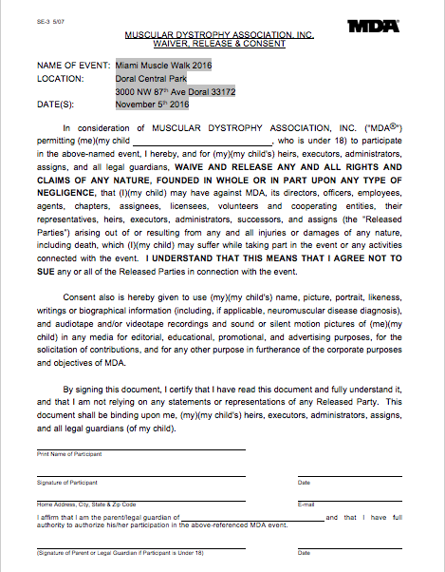

Moving Day

Date: Sunday, November 13, 2016, at Museum Park beginning at 8:30am.

About: This event will raise money to support people with Parkinson’s and their families and to support national research to improve the quality of life for those living Parkinson’s disease.

What is Parkinson: Parkinson’s is a neurological disease that affects both men and women in almost equal numbers, and it shows no social, ethnic, economic or geographic boundaries.

Sign up: www.MovingDayMiami.org

Check in: 6:30am and the event ends at 12:00pm.

Duties performed:
· Placing and picking up signs
· T-shirt distribution
· Directing walk participants from the parking lots and garage
· Helping at food/water stations
· Helping at the Movement Pavilion
· Other duties as needed

Can you please provide:
· Will you and your club be available for clean up/breakdown of the event?
· T-Shirt Size (names and sizes of all individuals)
· Waiver Attached (You can email or bring this to the event)
· What school/club do you attend?

Event Location:
Moving Day® Miami will take place at Museum Park 1075 Biscayne Blvd, Miami, FL 33132

Schedule of Events:
7:30 am Registration Opens 8:30am Warm Up Starts 9:00 am Opening Ceremony 10:00 am Walk Starts 11:30 am Awards/Closing Ceremony *Schedule subject to change

Volunteer form: file:///Users/melanie0042/Downloads/Moving%20Day%20Event%20Liability%20Waiver.pdf

